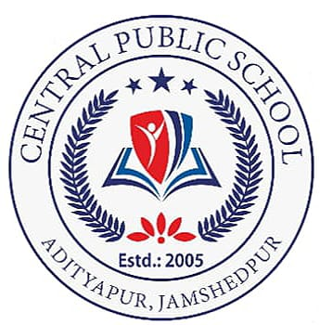
CENTRAL BOARD OF SECONDARY EDUCATION
CENTRAL PUBLIC SCHOOL
ADITYAPUR, JAMSHEDPUR

A PRACTICAL RECORD FILE IS SUBMITTED TO DEPARTMENT OF COMPUTER SCIENCE FOR THE PARTIAL FULLFILLMENT OF AISSCE EXAMINATION FOR THE ACADEMIC
SESSION: 2023-24

SUBMITTED BY: KAUSHAL PRAJAPATI
HOD(COMPUTER): MR. SOURAV ROY
CLASS: XII “A”
ROLL NO.: 22712731

